Revocation

**1)Revoke Perpetual Credential**

a) Generate Perpetual Credential 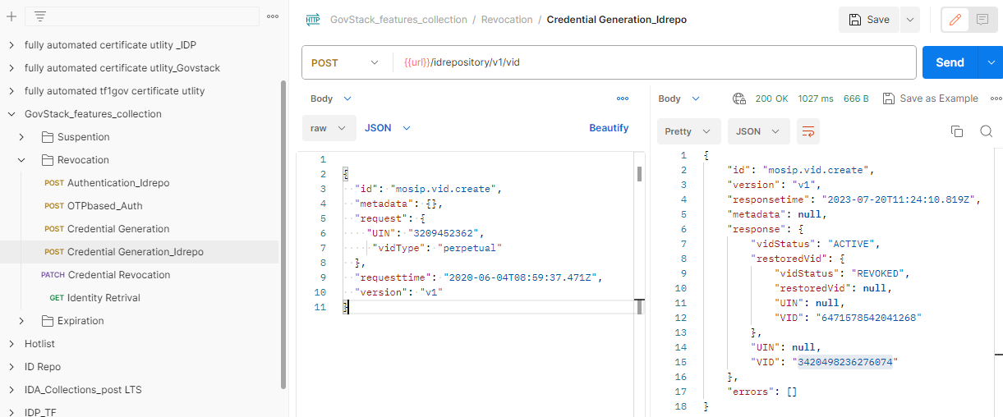

b) Revoking perpetual credential

* Note; - When we are revoking perpetual credential, the credential will revoke and new credential will generate automatically based on config 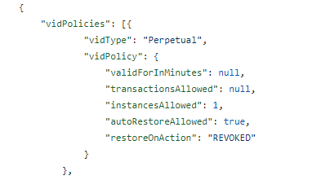

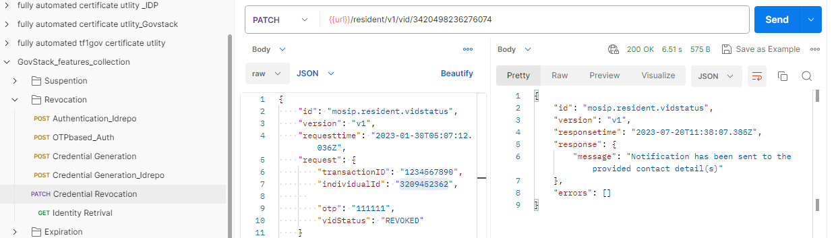

* Notification

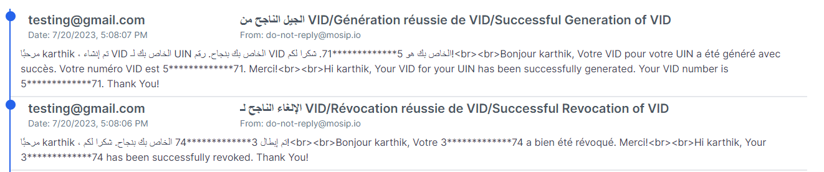

* Database

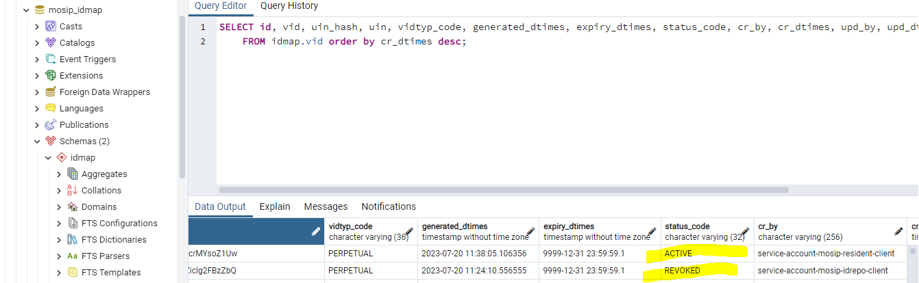

**2)Revoke Temporary Credential**

a) Generate Temporary Credential 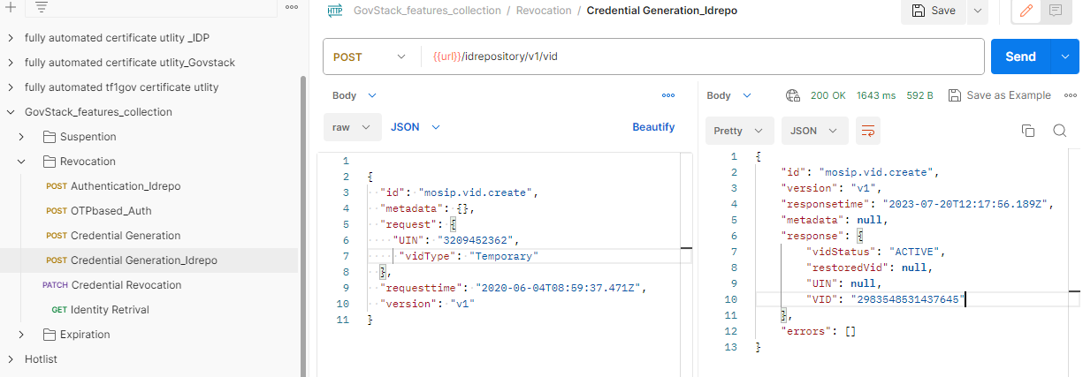

B) Revoking Temporary credential 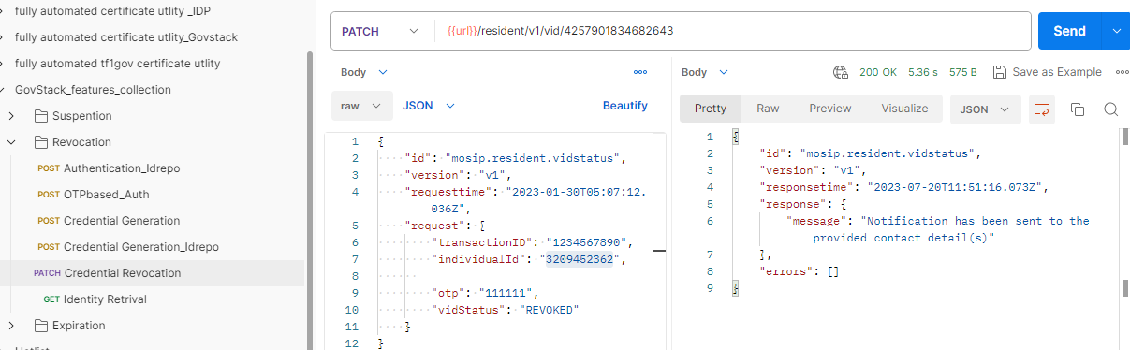

* Notification



* Database

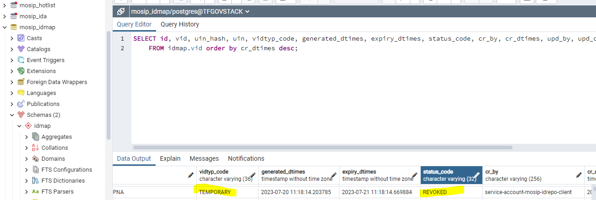

Integration Scenarios with revoked credentials.

a) Generate credential 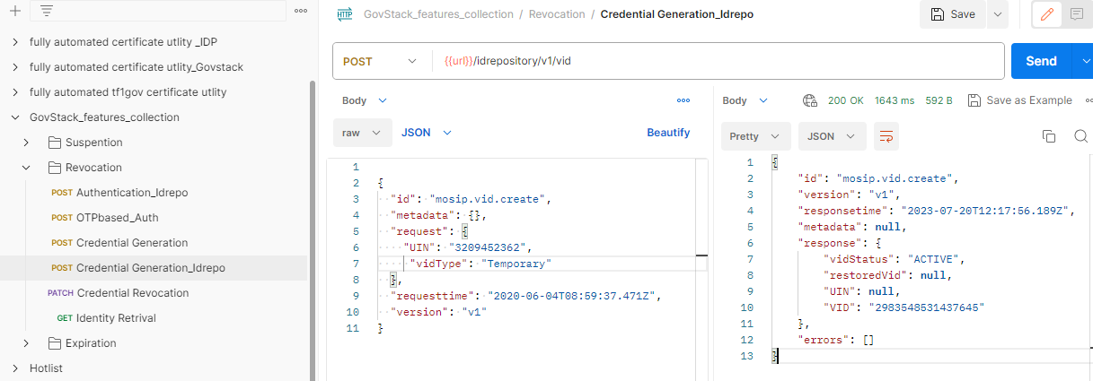

b) Revoke credential 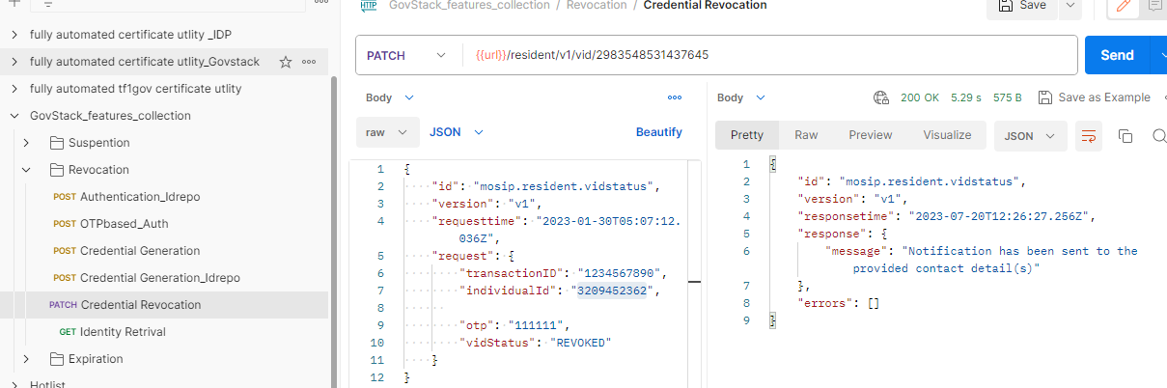

* Notification



1)Send OTP with revoked credential 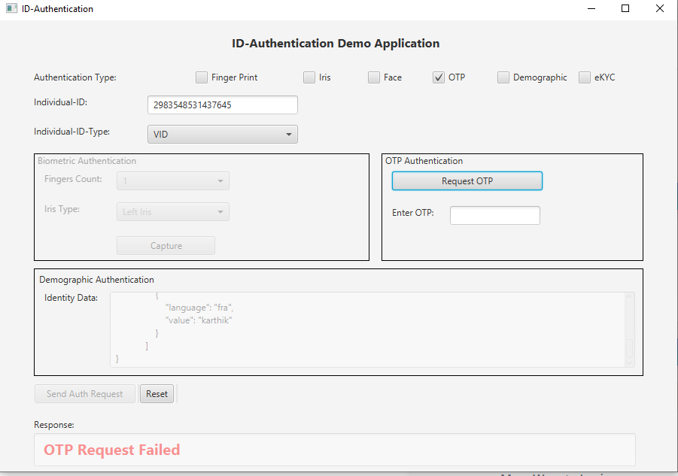

* console



2) Login resident service portal with revoked credential 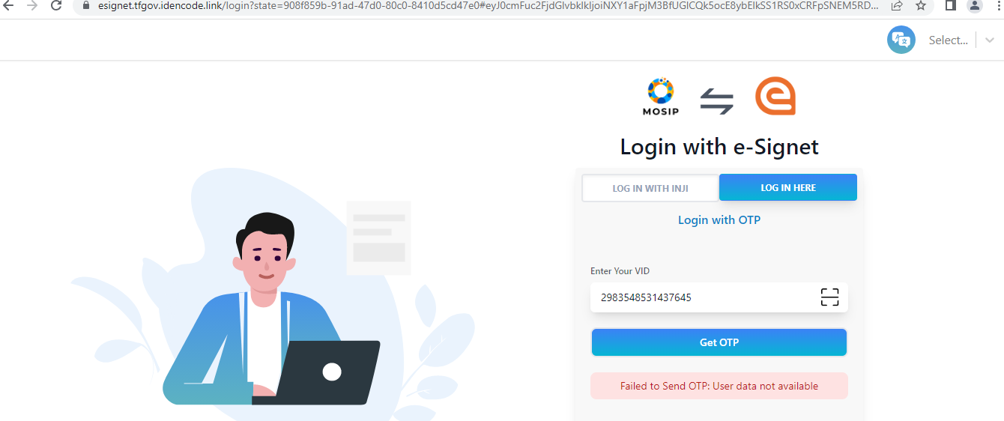

3) login Health service portal with revoked Credential 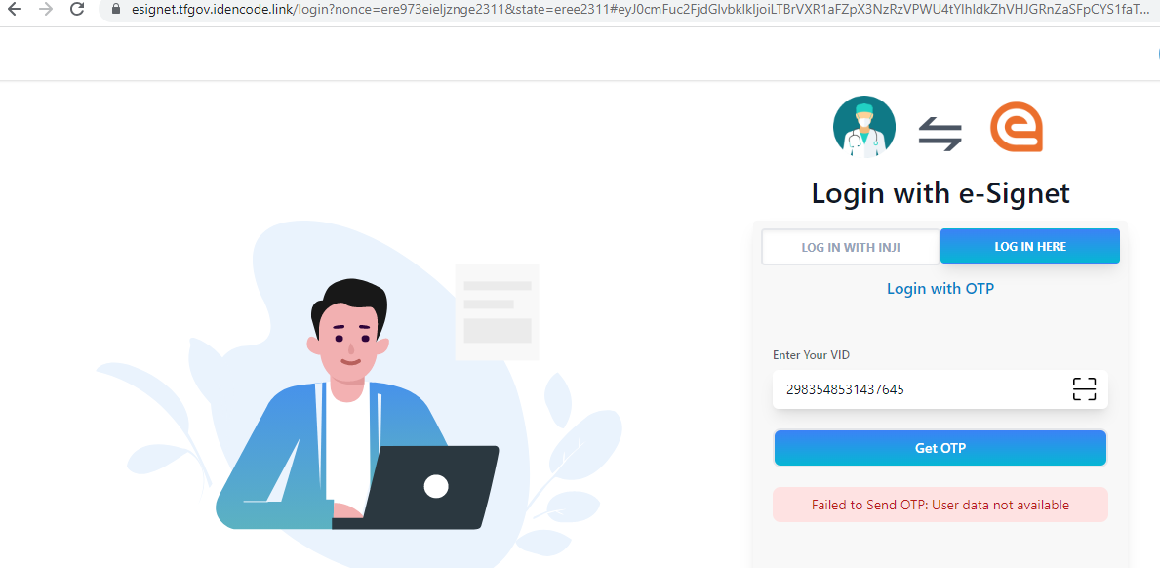

4) Not receiving VID expiry email notification for revoke credential after batch job run   
5) Revoked credential Not moving to VID Expiry list table

6) Fetch Revoked credential details via idrepo 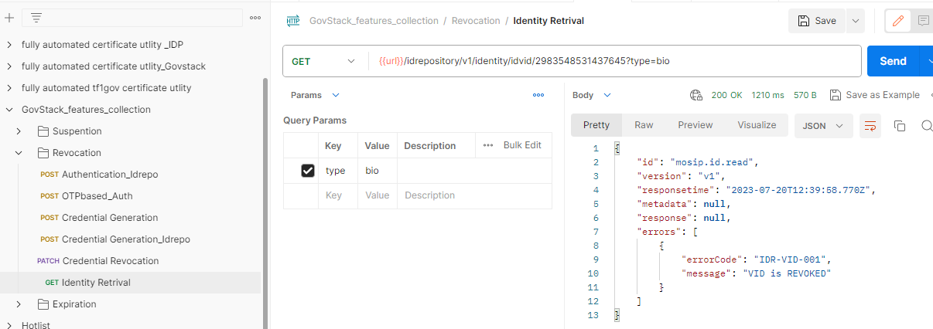

7) Bio Authentication with Revoked credential 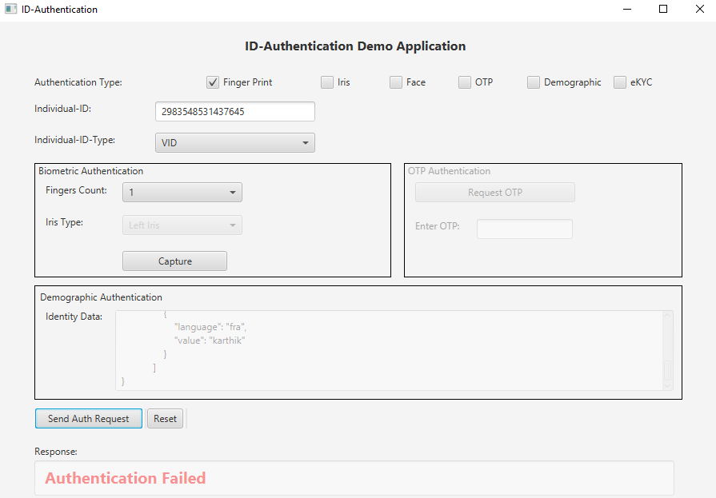

* Command Prompt



8) Demo Authentication with Revoked credential 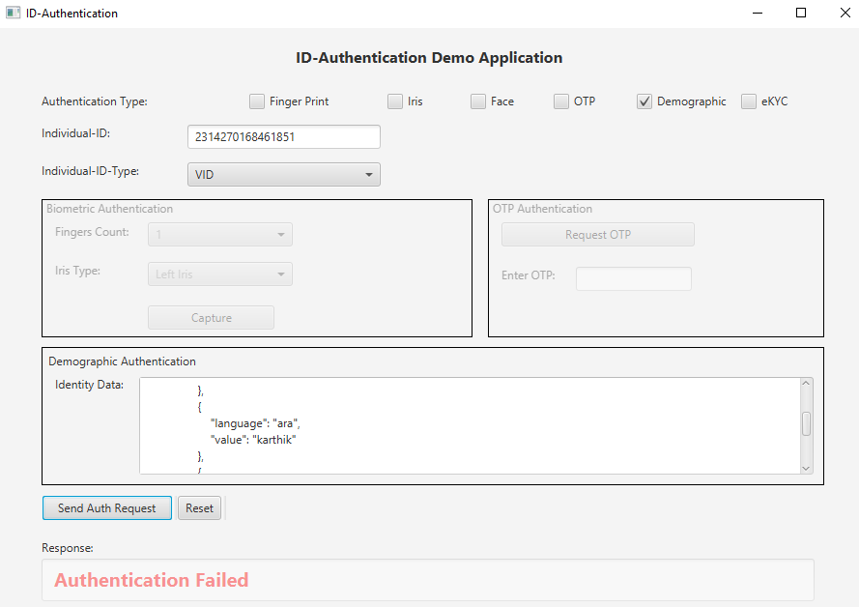

* Command Prompt



9) Suspend credential with Revoked Credential 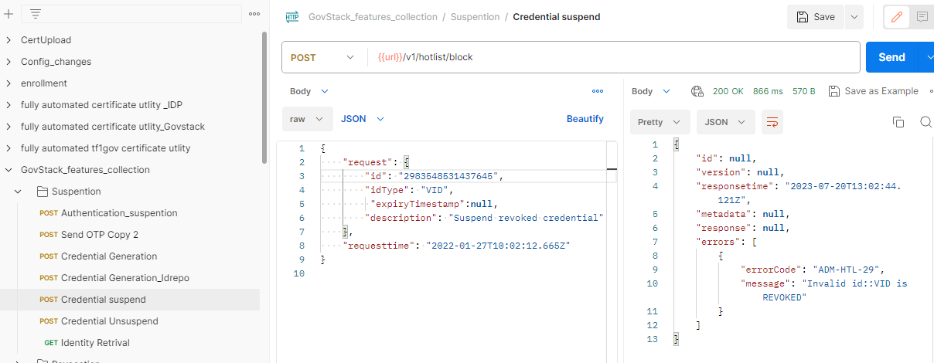

10)Send OTP with revoked credential to AUTH Lock 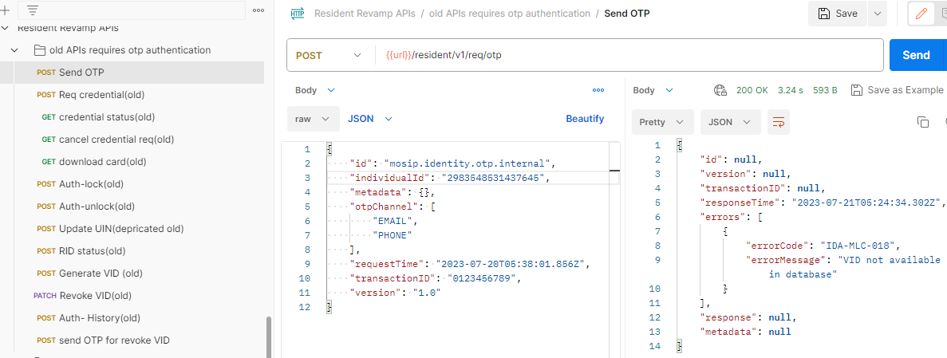

11)Send OTP With revoked credential to request credentials for download card 